- List=mutable , ordered, duplicate allowed
- Tuple= immutable, ordered
- Set= Unordered , duplicate not allowed
- Dictionary= Unordered collection of key value pairs
LOOPS
- *For loop: Used when you know number of iteration
- *While loop: iterates until the given condition is satisfied
Fibonacci Series:
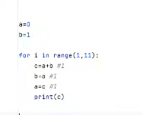

Finding max in list without using function
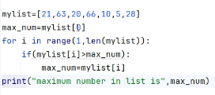

Swapping
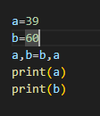
Mutiplication
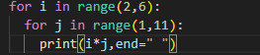
Diamond
n=5
for i in range(1,n+1):
for j in range(n-i):
print(" ",end=" ")
for k in range(2*i-1):
print("#",end=" ")
print()
for i in range(n-1, 0, -1):
for j in range(n-i):
print(" ",end=" ")
for k in range(2*i-1):
print("#",end=" ")
print()

